Once upon a time a train engine lived in New York City. She grew up
hearing stories about a little engine that could. She was different. She was

the Innovative Engine.

One day, a teacher sent her a letter with a special request.
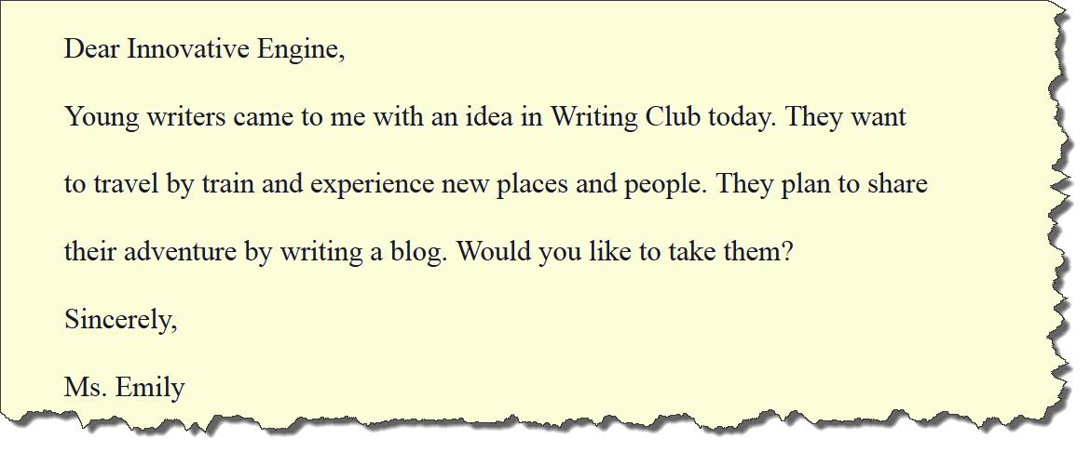

The Innovative Engine agreed. The young writers collected their notebooks, laptops and backpacks and took the NYC subway to Grand Central Station where they climbed aboard the Innovative Engine.

They sped down the tracks to the Capitol Building in Washington, D.C.
All 100 US Senators greeted the young writers while photographers’ flashes flared in the background. The lawmakers gave them a tour of the Capitol Building and promised to follow their blog.

The young writers discovered a candy shop and bought Chewy Cherry Chomp Chomps. They put their pennies on the rails for the Innovative Engine to flatten. She did not want to let them down, so she flashed by at full speed and flattened the copper circles into ovals. The young writers collected their new treasure, sprinted down the tracks and hopped back on. The curving country roads passed by as they gazed out the windows.

The Innovative Engine came upon the Appalachian Mountains, and pulled up on her brakes with a screeeeeeech. Steve, a young writer, wrote in his journal: “The mountains stretch on like giant gopher mounds as far as the eye can see.”
The Innovative Engine remembered the story of a little engine who believed in himself to make it over a mountain, but she stated, “I think I can, I think I can, I think I can come up with a better way!” She asked the young writers to blast a tunnel through the mountain using dynamite. Ssssssss, Pop, Pow, Boooooom!
Breathing her exhaust in the tunnel made everyone cough and wheeze. The young writers tucked their noses under their t-shirts. “I should run on renewable energy,” she thought aloud. The young writers researched solar energy and ordered solar panels online. They installed them the next day.
Churn, Burn, Turn! Flip, Flap, Snap!

Putting on solar panels was hard work. The Innovative Engine promised to take the young writers for a swim in Wisconsin, the land of 15,000 lakes.

On their way, a girl chased something near the tracks outside of Chicago. The young writers jumped off the train, wrote down what they witnessed and put their notes together to form their first online blog.

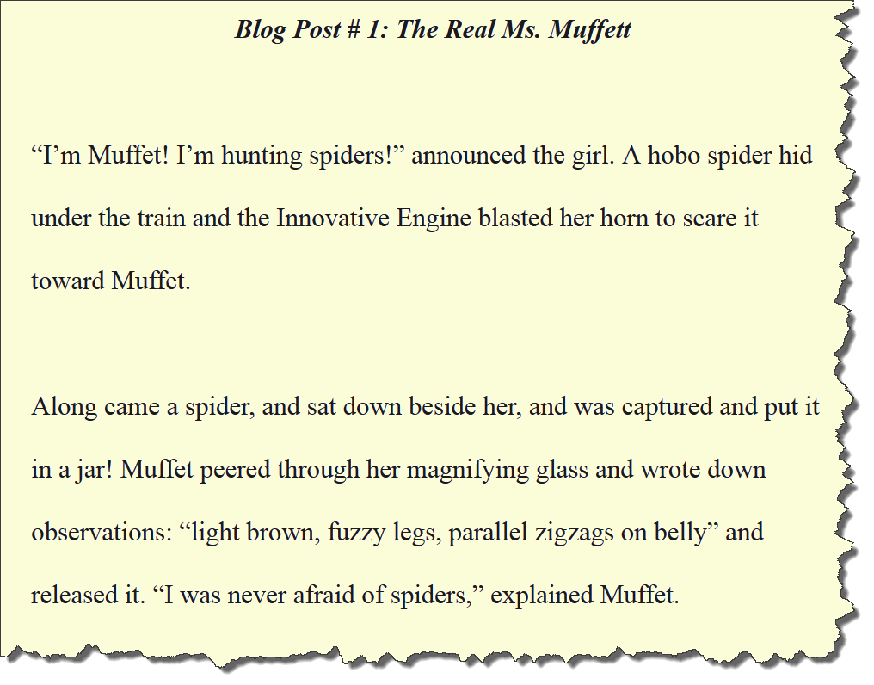

The young writers waved goodbye to Muffet as they travelled up the tracks to Spooner, Wisconsin. She dropped them off for a refreshing dip at the lake. One of them, Grove, stayed back to watch train videos on his iPad instead.

The Innovative Engine took them to the local train museum where they learned trains in Spooner were used to transport logs long ago. The town still used a train for their mascot.
They continued westward and passed wind turbines rotating in the breeze. The young writers stopped at an animal farm where they heard shouts coming from the chicken coop. They dashed over with their notebooks.

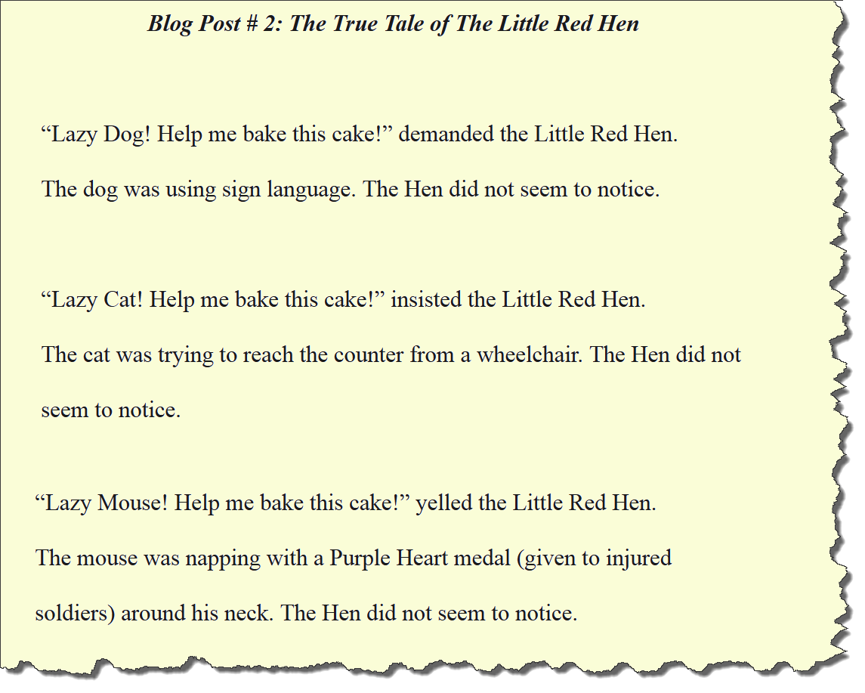

The farmer read their blog. He taught the Hen sign language, lowered the counters, and asked the Hen to let the snoozing mouse snore in peace.

The Innovative Engine loved her new solar panels, however, she wanted to breathe better AND be the fastest train in the world.
The young riders researched high-speed magnet trains and found a magnet train scientist named Dr. Linden in Mexico.

They followed the tracks south and waited to cross the border into Mexico. After a looooooong wait they found Dr. Linden living out in the desert.

“I can convert you into a high-speed magnet train, however, there is one problem. No magnetic tracks exist on the continent of North America!” Dr. Linden exclaimed.

The young writers discussed a solution to this problem. Martin declared, “Let’s design a dog sled with wheels and ask Iditarod racers to lay magnets on the rails!” He held up his iPad and flipped through pictures of the famous Iditarod dogsled race in Alaska where dogs pull humans on sleds across snow in the Arctic.

The young writers explored a local junkyard and tinkered with different pieces. They attached the sturdiest wheels they could find to a dog sled. They tweeted a picture of their creation. Iditarod racers converted their dogsleds and started laying magnets on the tracks all over North America.
Ring, Ding, Ping! Whack, Crack, Smack!

Meanwhile, Dr. Linden converted the Innovative Engine into a high-speed magnet engine by placing magnets underneath the whole train.
Clang, Bang, Pang! Flip, Dip, Slip!

Before zooming off, a boy named Jack heard the commotion and ran over.

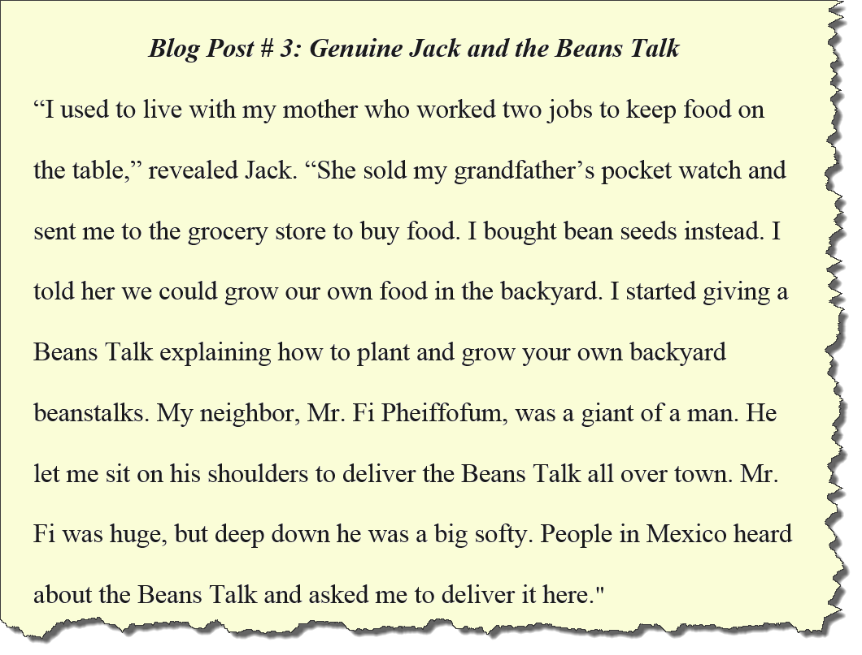

“I have an idea!” exclaimed a young writer named Maryam. “Let’s rip out all of the seats in a passenger car, shovel dirt inside and plant bean seeds! We would have a traveling garden to show people how to plant and grow beanstalks and Jack could come with us!” Everyone loved this idea, especially Jack. Slash, Crash, Thrash! Slam, Wham, Bam! Pieces of train went flying in all directions! The young writers were soaked with sweat from the Mexico sun when their project was finally done.

The Innovative Engine sped towards California. After an even loooooonger wait at the U.S.A/Mexico border she pulled up her brakes for a break in L.A.

Cars were stuck in traffic and orange smog hovered overhead.

They discovered a celebrity in a limousine, Cindy Rella. The young writers offered to show her their traveling garden. She ditched the limo and climbed aboard. Cindy Rella asked, “Why not just give people beans?” Jack shared, “If you give people beans, they will eat for a day. If you show people how to plant and grow beanstalks, they will eat for a lifetime.”

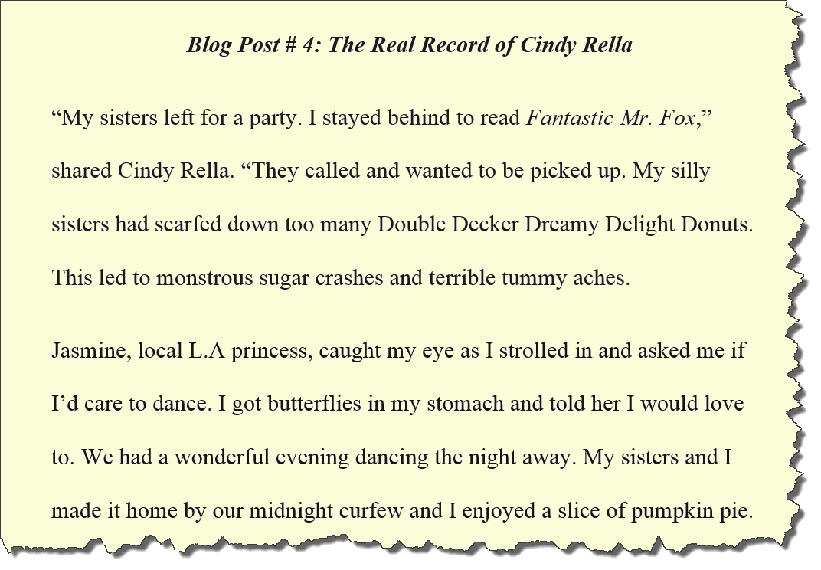

The Innovative Engine blasted on towards San Francisco. A tall man, with a rather dark beard, greeted them at the station. “Welcome to the land of innovation!” he announced. Adults on the platform stared down at their phones and did not seem to notice the arrival of the young writers.
Robot drones flew in and whisked the young writers away to a computer coding club where they designed and programmed a video game.

Afterward, the Innovative Engine took them out to a windy beach to view the Golden Gate Bridge. Debs, a young writer, inhaled the salty sea air and penciled: “Fog flows through the bridge like a river of cotton candy.” The fog was so peaceful they all dozily drifted into a dreamy sleep.

They awoke to the sun and were gone with the wind. As they zoomed past the Sierra Nevada mountains, Lucy, the quietest young writer, drafted: “Peaks rise like waves of ancient arrowheads attached to one another, frozen in time.” The Innovative Engine followed the transcontinental railroad tracks built long ago. Thanks to the Alaskan Iditarod racers they were now magnet rails. The world blurred by them like a runaway merry-go-round as the engine pressed on to New York City.

A crowd of people cheered and waved as they entered Grand Central Station in New York City. The Innovative Engine was now the fastest train in the world! The President of the United States showed up to greet them with a handshake and a big smile while photographers’ flashes flared in the background. The young writers were thanked for writing their blog.
Someone from the crowd shouted, “Are you looking forward to being home so you can play with your toys?” A young writer replied, “Toys can be broken, but stories last forever.” And the Innovative Engine, was happy.

Where can I learn more about the author and buy this book?

www.innovativeengine.wordpress.com
Gratitude

Many people are involved in a project like this. No author could ever do it alone.

I wish to thank you, the readers, for making writing fun as well as meaningful.

To my partner, Michelle Voss, for her love and suggestions.

To my brother, a talented tattoo artist and musician, for drawing the engine.

To my sister, a fellow teacher, for helping me “see the light bulb.”

To my parents, Don and Michelle, for driving us across the U.S. in our youth.

To Dustin Wells, who edited the original draft countless times.

To Dave Girdwood, for formatting the blogs and introducing me to Can Stock.

To Dr. William Weber, my original writing buddy in 9th grade.

To Sam Pearcy, for helping with the final line edits.

To everyone who offered advice along the way. I thank you all.

